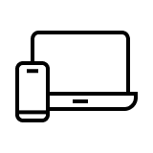


Devices
Cloud
Verkada Products
Ecosystem of hybrid cloud devices capable
of local storage and offline operation.
Deep analytics processed in real-time for instantaneous insights from any device.
At just 20-50 kbps, increase coverage across your organisation without limitations.
Verkada’s Hybrid-Cloud Architecture
Reliable Security
Monitor From Anywhere
Limitless Scale

